Collecting Attendance in Testing Nirvana
(Bobcat Brew Edition)

- Log into Testing Nirvana
  - www.testingnirvana.com
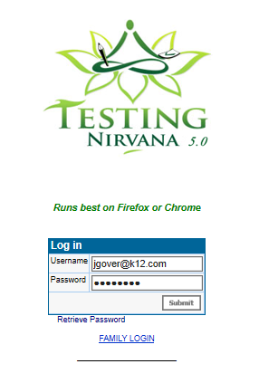

- Choose your event from the “Select an Event” list by clicking the blue arrow
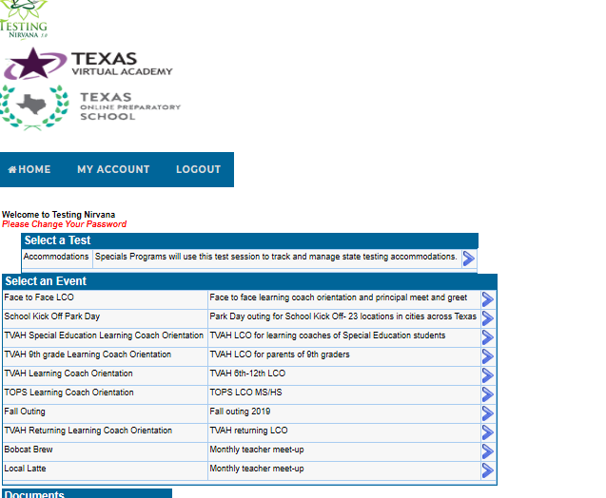
- Choose “Attendance” for “Where do you want to go?”
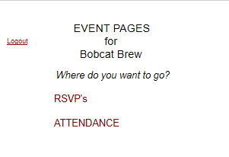

- Choose “Add Attendee”
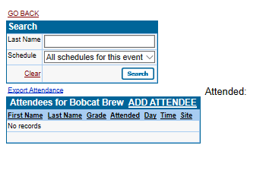
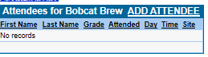

- From the list of site choices, choose your site by clicking “SELECT”
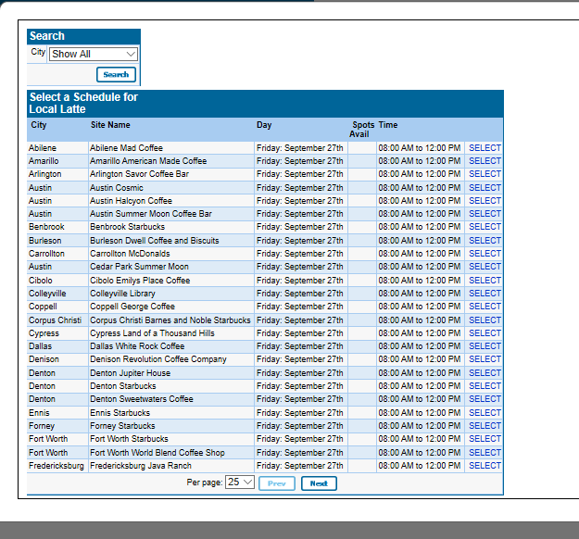
*Use the City Search feature to filter your site choices
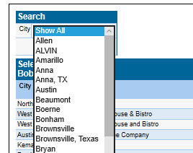
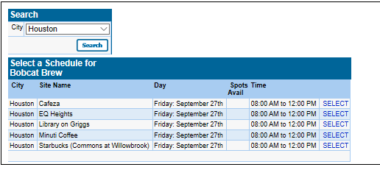

- Each LC that enters your event can enter their student’s first and last name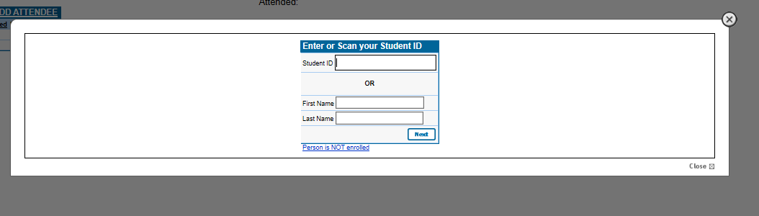
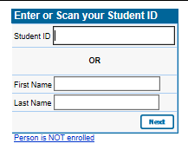
- Confirm that this is the student you are entering attendance for by choosing “yes”.
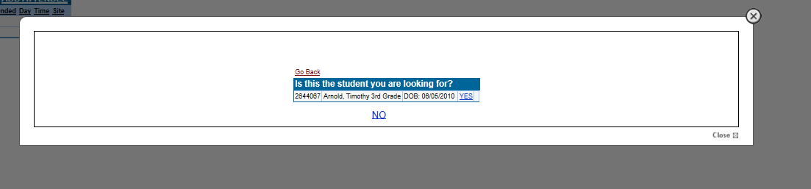
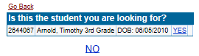

After choosing “yes”, Testing Nirvana will return you to this screen:
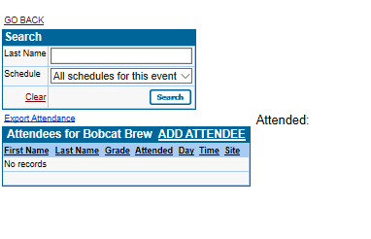
Follow steps 5-8 for each attendee that attends your event.

