CMAS Training Notes

- General Test Information
  - 3-8th grade
    - ELA
    - Math
    - Science - Grades 5 & 8
  - 11th grade
    - Science
  - Test Platform -Pearson Access Next - www.co.pearsonaccessnext.com
My Login:______________
My Password: ______________

- Testing Window - April ______________- ______________
- Testing Times
Math Grades 3-5 (non-calculator) - 65 minutes per section
ELA Grades 3-5 - 90 minutes per section
Science Grade 5 - 80 minutes per section

Math Grades 6-8 - (non-calculator & calculator) 65 minutes per section
ELA Grades 6-8 - 110 minutes per section
Science Grade 8 - 80 minutes per section

Science - Grade 11 - 50 minutes per section

- Guidelines for Administration Time
  - Each day, 3-8 students will test one section of ELA and one section of Math
  - Once the testing time is met, the unit must ______________. There is no ______________ test time

- Before Testing
  - Let students choose their own ______________
    - Check accommodation list for “Preferred Seating” students
  - Collect all ______________ ______________, wearable technology, music players, tablets/e-readers, reference books, electronic pens, etc and keep them in the front of the room
    - Proctors may have a cell phone on silent to text SC if help is needed. NO other use permitted!
  - Pass out pencils & ______________ if needed
  - Hand out student ______________ ______________
    - If you are missing a test ticket, let your Site Coordinator know immediately or pull one on your own
  - Store snacks and drinks away from the computers (if allowed at site) on the floor, at the front/back of the room, etc.
  - Student-to-Proctor ratio must not exceed ______________. to 1
  - Students should not be able to see each other’s work
- Tasks to Complete the Day of Testing
  - Receive the test materials
  - Manage test sessions in PANext
  - Read the appropriate “SAY” directions from the TAM
  - Distribute test materials to students - test tickets, scratch paper, etc.
  - Help students log into ______________ ______________
  - Keep/monitor time
  - Supervise and monitor test activity
  - Provide ______________- minute stand and stretch breaks, if needed
  - Report testing irregularities or security breaches to the Test Coordinator
- PearsonAcess^{next} Navigation
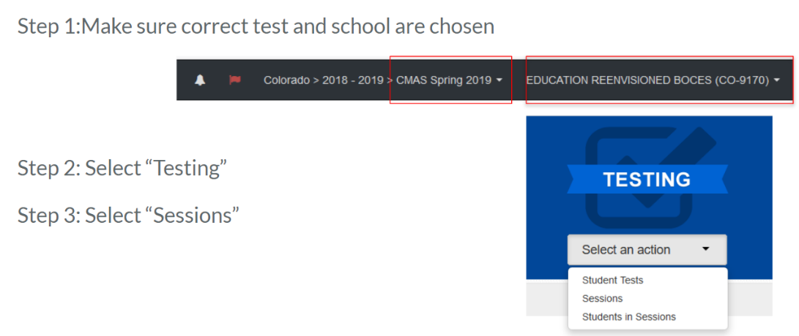
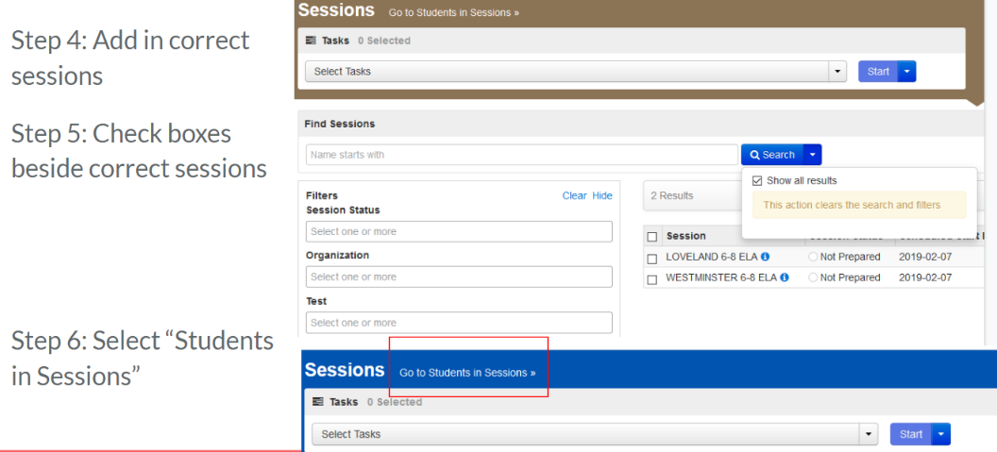

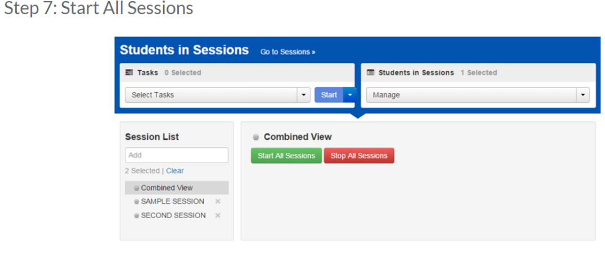
Step 8: Unlock sessions students are testing in. Lock again when they are finished.
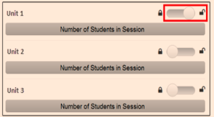

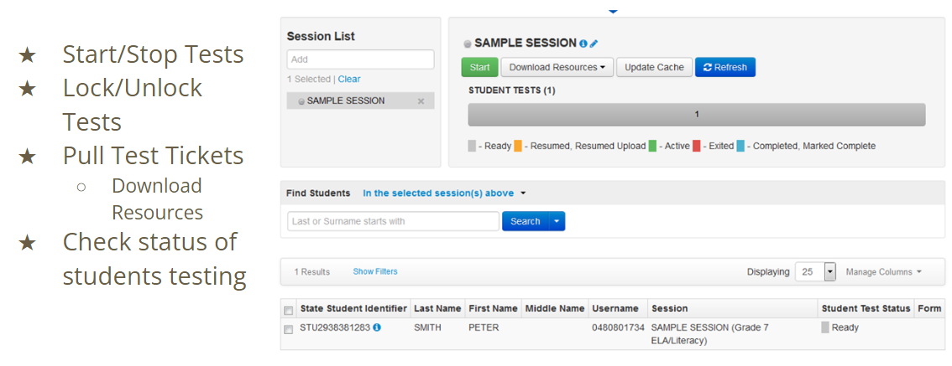
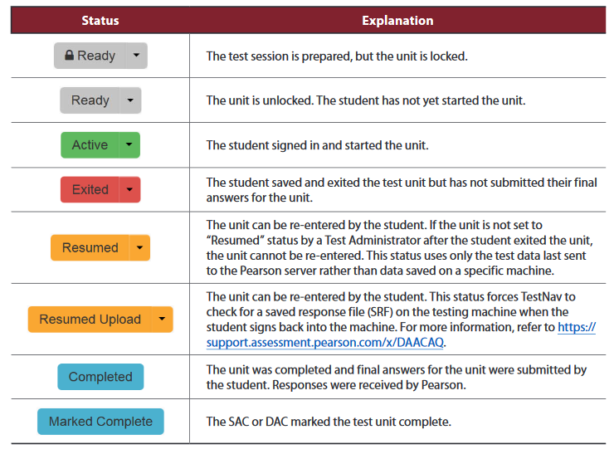
- Post the following Unit Timing Box
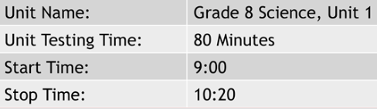

- What I can/can’t do as a proctor

Can | Can’t
- Ensure students have all necessary materials for each unit  - Ensure a standardized testing environment  - Read SAY directions exactly as written  - Move throughout the room during testing -”______________ ______________”  - Re-read/clarify SAY directions to students when asked  - Use proximity to keep students on task  - Use “continue working” script  - Remain attentive and in the room during the entire testing unit  - Circulate throughout the room during the test  - Should be able to see ______________ , ___________, not ___________. _______________ . | - Provide feedback  - ______________test questions  - Answer content-related questions  - Interfere with students’ demonstration of skills  - Interact with students in any way that would impact their responses  - Engage in ______________. ______________ during the session  - Read sources, passages, questions or student responses  - Help with ______________ ______________  - Allow students to communicate in any way or use prohibited materials  - Leave test materials unsecured  - Discuss or disclose test content through verbal exchange, social media, email, or any form of communication

- Break Time Guidelines
  - Students may not have a cell phones during scheduled break
  - Students need to keep food and drinks away from the computers
  - Restroom breaks during testing don’t stop the clock
- Testing Interruptions
  - Phone Goes Off or is Found in Student's Possession During Testing
    - On student -dismiss from the test and notify the Test Coordinator to invalidate the test
    - Not on student -give a warning and turn off the technology
Secure | Non-Secure
- Student Testing Tickets  - Papers with student accommodations  - Oral scripts  - ______________ scratch paper  - Any student work/responses | - Test Administrator ______________ (TAM)  - Procedures Manual  - Unused scratch paper

- Finishing the Test Session
  - Guidelines for Administration Time
    - Schedule the entire amount of unit testing time
    - Once the unit testing time is met, the unit must end
    - If all students complete testing before the testing time is met, the unit ______________ ______________ ______________
    - Students who end early may read a book or sit quietly
  - Student Submits Test
- Check test status in PAnext to show Complete. If a student is Active but no longer signed into PAnext, Resume their test and have them sign out properly again
- End of testing session
  - Lock the tested unit at the session level
- Make-Up Scheduling
- Test units must be administered to students in ______________ order
- Room Combining Requirements- don’t test the following together:
  - ELA and mathematics (unit testing times and administration SAY directions are different)
  - Science/social studies and ELA/math (unit testing times and administration SAY directions are different)
  - High school science/social studies and elementary/middle school science/social studies (different unit times)
  - Math grades 3-5 and math grades 6-8 (different administration SAY directions)
  - Math grades 6-8 unit 1 and math grades 6-8 units 2 and 3 (different administration SAY directions)
- Troubleshooting Guidance
- When a technology disruption affecting a ______________ student occurs, Test Administrators take the following steps:
  - Note the time of the disruption
  - Follow procedures for troubleshooting and support
  - If the issue persists, move the student to another testing device
  - the situation in writing
- When a technology disruption affecting ______________ students occurs, Test Administrators take the following steps:
  - Pause testing
  - Note the time of the disruption
  - Follow procedures for troubleshooting and support
  - Resume testing
  - Document the situation in writing
- Troubleshooting Resources
  - Included in Assessments Website

