K12 Families,
You have been invited to an online session to take the Star360 assessments from home. To ensure a timely testing experience, please have the following 5 steps checked and completed prior to the testing session.
Step 1: Ensure you are using either Google Chrome or Mozilla Firefox as your browser.
If you don’t have these downloaded on your computer, please do so by selecting one of these links:
Google Chrome – https://www.google.com/chrome/?brand=CHBD&gclid=CjwKCAjw1_PqBRBIEiwA71rmtfWsqPYn2j9uTbCIe-MIzOLdrNL2Hv6g60Zf-9gwjeKhJx7fFmg0nhoCpO0QAvD_BwE&gclsrc=aw.ds
Mozilla Firefox - https://www.mozilla.org/en-US/firefox/campaign/?utm_source=google&utm_medium=cpc&utm_campaign=Firefox-Brand-US-GGL-Exact&utm_term=mozilla%20firefox&utm_content=A144_A203_A006337&&gclid=CjwKCAjw1_PqBRBIEiwA71rmtXOEdvfWNWJ4IoPbgv0XaDYUT4E8LdhvlC3z5j2TJo_Krx7p3WBzQRoCBaQQAvD_BwE&gclsrc=aw.ds
Step 2: If you already have Chrome or Firefox, please ensure that you have the most updated version and have cleared your cache.
Chrome
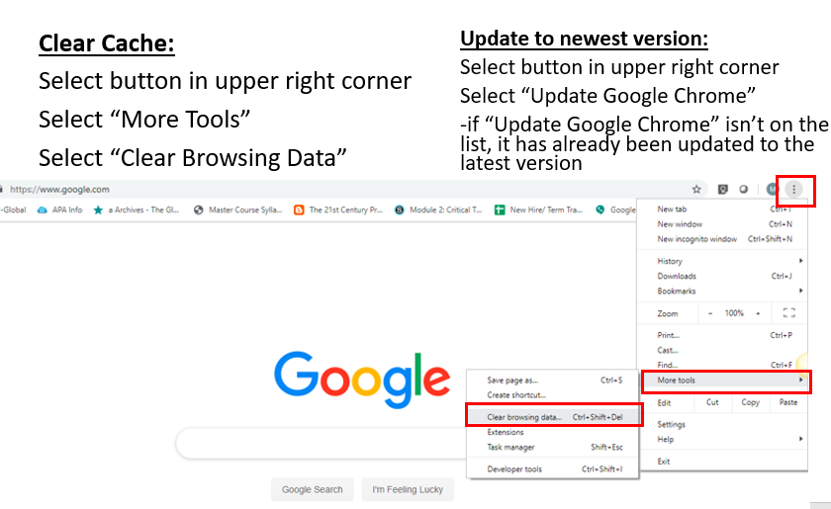

Firefox
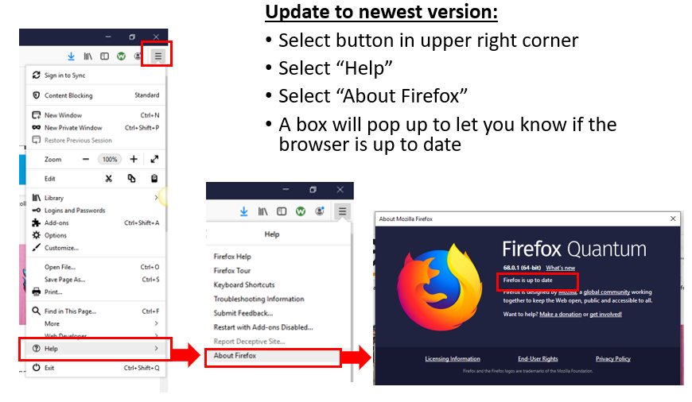
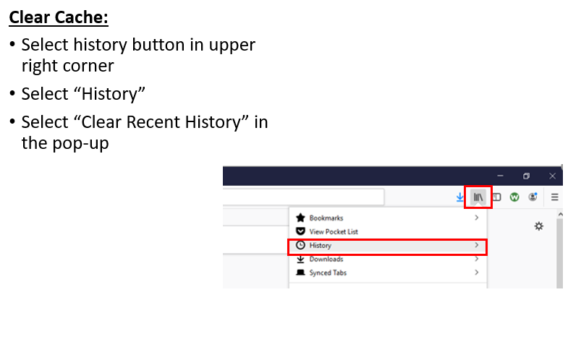

Step 3: Ensure you have a working microphone

A computer microphone will work sufficiently if you don’t have a headset. Some teachers have found that a set of earbuds with a microphone can even work if no other options are available.

Step 4: Prepare for Zoom.

This is an online meeting room used by our staff for webcam usage.
View this very brief video to understand how to launch Zoom once the teacher shares the link after the students are together in the Blackboard Collaborate session - https://www.youtube.com/embed/vFhAEoCF7jg?rel=0&autoplay=1&cc_load_policy=1

-If you can’t access Zoom on your computer, you can download the app on a smartphone or tablet and have that available to sign in during the session. Search in your phone’s App store for the app download link. Please complete the download prior to the test session since it may take some time to download and load.

Step 5: Check to make sure you can see your meeting time and date in your Class Schedule. Enter the online session when it is time. If you have followed these steps, you are ready to test!

All testing links, usernames and passwords will be shared with the students once they are in the session together.

